AI-Driven Cyber Anomaly Detection and Secure
Audit Logging Framework
GUIDE: Mrs.R.Ranjani.,M.E.,ASP CCET
CO-ORDINATOR:Mr.Mani.J.,M.E.,P.hd.,M.I.S.T.E. CCET
Abdul pathiaq. A,
David raj. M,
Gopinath. G,
Jayapradap. J
DEPARTMENT OF INFORMATION TECHNOLOGY, CCET-605510

ABSTRACT - Cybersecurity has become one of the most critical challenges in modern digital environments due to the rapid increase in sophisticated and evolving cyber threats. Traditional intrusion detection systems, which rely heavily on static signatures and predefined rules, often fail to detect zero-day attacks and advanced persistent threats. This limitation highlights the need for intelligent, adaptive, and real-time threat detection mechanisms.In this paper, we propose an AI-Driven Cyber Anomaly Detection and Secure Audit Logging Framework (CAD), designed to enhance the detection of anomalous activities through behavioral analysis and dynamic risk assessment. The system leverages a hybrid approach combining rule-based techniques with intelligent scoring mechanisms to analyze user and network activities. Each event is processed through multiple stages, including preprocessing, keyword extraction, and contextual evaluation, to generate a dynamic risk score on a scale of 0 to 100.Based on the computed score, activities are classified into three categories: low, medium, and high risk, enabling efficient prioritization of threats. In addition to detection, the framework incorporates a secure audit logging mechanism that ensures all events are recorded in a structured and tamper-resistant manner, improving transparency, accountability, and forensic analysis capabilities.The proposed system also features a web-based interactive dashboard that provides real-time visualization of detected anomalies.This enhances situational awareness for administrators and supports faster decision-making. Experimental evaluation of the system demonstrates improved detection efficiency and reduced false positive rates compared to conventional rule-based systems.Overall, the CAD framework presents a scalable and effective solution for modern cybersecurity challenges, with the potential for further enhancement through integration with advanced machine learning models and blockchain-based security mechanisms.
I. INTRODUCTION
In recent years, the rapid expansion of digital technologies, cloud computing, and interconnected systems has significantly increased the risk of cyber threats. Organizations and individuals are continuously exposed to various forms of attacks such as malware, phishing, insider threats, and advanced persistent attacks. Traditional cybersecurity mechanisms, particularly signature-based intrusion detection systems, are no longer sufficient to handle these evolving and sophisticated threats.These conventional systems depend heavily on predefined rules and known attack patterns, making them ineffective against zero-day attacks and unknown vulnerabilities. Additionally, they often produce high false positive rates, leading to inefficiencies in threat analysis and response. This creates a critical need for intelligent and adaptive security systems capable of identifying anomalies in real time.To address these challenges, this paper introduces CAD (AI-Driven Cyber Anomaly Detection and Secure Audit Logging Framework), a hybrid cybersecurity solution designed to enhance threat detection through behavioral analysis and dynamic risk evaluation. Unlike traditional approaches, CAD focuses on analyzing user and system activity patterns to identify deviations that may indicate potential threats.The proposed CAD framework incorporates a multi-stage detection process, including data preprocessing, feature extraction, and risk scoring. Each activity is evaluated and assigned a dynamic risk score, which is further classified into low, medium, or high-risk categories. This enables efficient prioritization and faster response to critical threats.In addition to anomaly detection, CAD integrates a secure audit logging mechanism that records all system activities in a structured and tamper-resistant format. This feature ensures transparency, accountability, and supports effective forensic analysis in case of security incidents.Furthermore, the system includes a web-based interactive dashboard that provides real-time monitoring and visualization of detected anomalies, risk levels, and system performance. This improves situational awareness and assists administrators in making informed decisions.Overall, the CAD framework aims to provide a scalable, efficient, and intelligent solution for modern cybersecurity challenges, bridging the gap between traditional detection systems and advanced AI-driven security mechanisms.
II. LITERATURE OVERVIEW
The field of cybersecurity has witnessed significant advancements in recent years, particularly in the area of anomaly detection using Artificial Intelligence and Machine Learning techniques. Numerous research works have focused on improving the detection of cyber threats by analyzing patterns, behaviors, and network activities.
Traditional intrusion detection systems (IDS) primarily rely on signature-based techniques, which compare incoming data with known attack patterns. While these systems are effective in detecting previously identified threats, they fail to recognize unknown or zero-day attacks. To overcome this limitation, researchers have explored anomaly-based detection methods that identify deviations from normal behavior.
A. Patcha and J. M. Park (2022) provided a comprehensive overview of anomaly detection techniques, highlighting the importance of statistical and machine learning approaches in identifying unusual patterns in network traffic. Their study emphasizes that anomaly detection systems are more adaptable to new and evolving threats compared to traditional methods.
S. Axelsson (2021) discussed the challenges associated with intrusion detection systems, particularly the issue of high false positive rates. The study suggests that intelligent systems must balance detection accuracy with efficiency to avoid overwhelming security analysts with unnecessary alerts.
M. Tavallaee et al. (2023) analyzed various intrusion detection datasets and emphasized the importance of high-quality data for training accurate detection models. Their research highlights that improper dataset selection can significantly impact the performance of machine learning-based systems.
Y. Liao et al. (2022) explored the application of machine learning algorithms in intrusion detection, demonstrating how supervised and unsupervised learning techniques can improve detection accuracy. The study also suggests that hybrid models can outperform standalone approaches.
J. Zhang et al. (2024) investigated the use of deep learning techniques in cybersecurity, showing that advanced models such as neural networks can effectively detect complex attack patterns. However, these approaches often require high computational resources and large datasets.
Despite these advancements, most existing systems face limitations such as high computational complexity, lack of real-time processing, insufficient interpretability, and absence of secure logging mechanisms. Many solutions focus solely on detection without ensuring proper storage and traceability of detected events.
To address these gaps, the proposed CAD (AI-Driven Cyber Anomaly Detection and Secure Audit Logging Framework) integrates anomaly detection with dynamic risk scoring and secure audit logging. Unlike existing systems, CAD not only detects threats but also provides a structured, tamper-resistant logging mechanism along with a real-time visualization dashboard, making it a more comprehensive and practical cybersecurity solution.
In recent years, cybersecurity research has significantly evolved with the integration of Artificial Intelligence (AI) and Machine Learning (ML) techniques for anomaly detection. Modern approaches focus on identifying deviations in system and network behavior rather than relying solely on predefined attack signatures.
In 2025, Almuhanna and Dardouri proposed a hybrid deep learning and machine learning model for anomaly-based intrusion detection, combining techniques such as autoencoders, graph neural networks, and ensemble learning. Their approach demonstrated improved detection performance by leveraging multiple models, highlighting the effectiveness of hybrid AI techniques in cybersecurity.
Similarly, a 2025 study published in Scientific Reports introduced an AI-driven cybersecurity framework for anomaly detection in critical infrastructures such as power systems. The research emphasized feature extraction and real-time data processing, showing that AI-based systems can effectively detect anomalies in complex environments with high-dimensional data.
Another significant contribution in 2025 explored anomaly detection in encrypted network traffic using self-supervised learning. This approach addressed a major challenge in cybersecurity, where encrypted data limits visibility. The study demonstrated that self-supervised models can identify hidden patterns without requiring labeled datasets, improving detection capability in secure communication environments.
In addition, Chourasiya et al. (2025) developed an advanced log-based anomaly detection system using LSTM and transformer networks. Their model analyzed system logs for cyber forensic investigation, achieving higher accuracy in detecting complex attack patterns. However, such deep learning models require high computational resources and large datasets, which may limit real-time deployment.
Research in 2025 also explored the integration of blockchain with cybersecurity systems. A study on IoT security proposed a deep neural network combined with blockchain technology to enhance anomaly detection and ensure secure data storage. This approach improves data integrity and prevents tampering, but introduces additional system complexity and overhead.
Furthermore, Gulzar and Mustafa (2025) proposed a deep learning-based framework for anomaly detection in industrial control systems. Their work highlighted the importance of real-time monitoring and adaptive learning in detecting cyber-attacks in critical infrastructures.
Moving towards recent advancements, a 2026 review on graph-based anomaly detection emphasized the importance of handling large-scale and heterogeneous data in cybersecurity systems. The study pointed out that traditional methods struggle with scalability and dynamic environments, encouraging the use of graph-based and context-aware models.
Additionally, a 2026 survey on AI techniques for anomaly detection in smart grid systems highlighted that while AI improves detection accuracy, challenges such as interpretability, real-time performance, and secure logging still remain unresolved.
III. PROBLEM STATEMENT
The rapid growth of digital systems, cloud computing, and networked environments has significantly increased the volume and complexity of cyber threats. Modern attacks such as zero-day exploits, insider threats, and advanced persistent threats (APTs) are becoming more sophisticated, making them difficult to detect using traditional cybersecurity mechanisms.Most existing intrusion detection systems (IDS) are based on signature-based or rule-based approaches, which rely on previously known attack patterns. While these methods are effective for detecting known threats, they fail to identify unknown or evolving attacks, resulting in serious security vulnerabilities. Additionally, these systems often generate a high number of false positives, which can overwhelm security analysts and reduce the overall efficiency of threat response.Another major limitation of current systems is the lack of real-time intelligent analysis and dynamic risk evaluation. Many systems do not provide a clear prioritization of threats, making it difficult to distinguish between critical and non-critical events. Furthermore, existing solutions often lack a secure and tamper-resistant logging mechanism, which is essential for maintaining data integrity, ensuring accountability, and supporting forensic investigations.Moreover, most available solutions focus either on detection or logging, but not both in an integrated manner. This creates a gap in building a comprehensive cybersecurity framework that is both efficient and reliable.Therefore, there is a strong need for a unified system that can perform real-time anomaly detection using intelligent techniques, assign dynamic risk scores for better decision-making, and securely log all activities in a tamper-resistant format. The proposed CAD (AI-Driven Cyber Anomaly Detection and Secure Audit Logging Framework) is designed to address these challenges by providing an integrated, scalable, and practical cybersecurity solution.
IV. OBJECTIVES
The primary objective of this work is to design and develop an intelligent cybersecurity framework, namely CAD (AI-Driven Cyber Anomaly Detection and Secure Audit Logging Framework), that enhances the detection and management of cyber threats in modern digital environments. The system aims to implement an anomaly-based detection mechanism that analyzes user and network behavior to identify suspicious activities in real time. A key objective is to incorporate a dynamic risk scoring model that evaluates each activity on a scale and classifies it into low, medium, or high-risk categories, thereby enabling efficient prioritization of threats.Furthermore, the framework seeks to provide real-time monitoring and analysis through an interactive web-based dashboard, improving situational awareness and decision-making for system administrators. Another important objective is to design and implement a secure and tamper-resistant audit logging mechanism that ensures all detected events are recorded in a structured and reliable manner, supporting transparency, accountability, and forensic investigation. In addition, the system is intended to be lightweight, scalable, and easy to deploy, making it suitable for practical applications. Overall, the objective of CAD is to bridge the gap between traditional detection systems and advanced AI-driven cybersecurity solutions by integrating detection, risk assessment, and secure logging into a unified framework.Another key objective of the CAD framework is to improve the accuracy and efficiency of anomaly detection by minimizing false positive and false negative rates. The system is designed to intelligently analyze activity patterns and differentiate between normal and malicious behavior with higher precision. By incorporating a structured scoring mechanism and contextual evaluation, the framework ensures that only relevant threats are highlighted, thereby reducing unnecessary alerts and improving the overall reliability of the detection system. The framework also aims to ensure seamless integration between different system components, including the detection engine, risk scoring module, and audit logging system. This integration is intended to create a unified workflow where data flows efficiently from input to analysis and storage. Additionally, the system focuses on providing a user-friendly interface that allows administrators to easily monitor system activity, interpret results, and take appropriate actions without requiring extensive technical expertise. Another important objective is to design the system with future scalability and extensibility in mind. The CAD framework is structured in a modular manner, allowing the integration of advanced technologies such as machine learning models, deep learning algorithms, and blockchain-based security mechanisms in the future.
V. PROPOSED SYSTEM
The proposed system, CAD (AI-Driven Cyber Anomaly Detection and Secure Audit Logging Framework), is designed as a comprehensive and intelligent cybersecurity solution that integrates anomaly detection, dynamic risk assessment, and secure audit logging into a unified framework. The system adopts a behavior-based approach to identify potential cyber threats by analyzing user activities, system interactions, and network events in real time. Unlike traditional signature-based systems that rely on predefined attack patterns, CAD focuses on detecting deviations from normal behavior, enabling it to identify unknown and evolving threats effectively. The framework consists of multiple interconnected modules, including a user interface, detection engine, risk scoring module, audit logging system, and backend processing unit, all working together to ensure efficient threat detection and management.At the core of the system lies the detection engine, which processes incoming data through preprocessing techniques such as normalization, keyword extraction, and contextual analysis. Based on this processed data, the system applies a rule-based and scoring-driven mechanism to evaluate the severity of each activity. A dynamic risk score is assigned on a scale ranging from 0 to 100, which is further categorized into low, medium, and high-risk levels. This classification enables efficient prioritization of threats and assists administrators in focusing on critical issues first. The system is designed to operate in real time, ensuring that anomalies are detected and evaluated instantly, thereby reducing response time and improving overall system security.
In addition to detection and risk assessment, CAD incorporates a secure audit logging mechanism that records all analyzed events in a structured and tamper-resistant format. This ensures data integrity and provides a reliable source of information for forensic analysis and compliance requirements. The logging system is designed to maintain transparency and accountability by preserving detailed records of system activities, including timestamps, risk levels, and event descriptions. Furthermore, the framework includes a web-based interactive dashboard that visually represents system activity, detected anomalies, and risk distributions through charts and real-time updates. This enhances situational awareness and simplifies monitoring for administrators.
The proposed system is designed to be lightweight, scalable, and easy to deploy, making it suitable for both academic and practical applications. Its modular architecture allows future integration with advanced technologies such as machine learning algorithms, deep learning models, and blockchain-based security systems to further enhance its capabilities. Overall, CAD provides a balanced solution that combines efficiency, accuracy, and security, addressing the limitations of existing systems while offering a practical and extensible approach to modern cybersecurity challenges.
VI. METHODOLOGY
The methodology of the proposed CAD framework follows a structured and systematic approach to detect cyber anomalies, assess their severity, and securely log all activities. The process begins with input collection, where user activities or network events are captured in real time. These inputs may include login attempts, command executions, or system interactions. The collected data is then passed through a preprocessing stage, where it is cleaned, normalized, and transformed into a suitable format for analysis. This step may also involve keyword extraction and basic pattern identification to simplify further processing.Following preprocessing, the detection engine analyzes the processed data using a rule-based and behavior-driven approach. The system compares the incoming activity against predefined patterns and behavioral expectations to identify any deviations that may indicate suspicious behavior. Once an anomaly is detected, the risk scoring module evaluates the severity of the activity by assigning a dynamic score on a scale of 0 to 100. This score is calculated based on factors such as keyword intensity, frequency of occurrence, and contextual relevance. Based on the computed score, the activity is classified into low, medium, or high-risk categories.After classification, the results are forwarded to the audit logging module, where all events are stored in a structured and tamper-resistant format. Each log entry includes details such as timestamp, activity description, risk score, and classification level, ensuring transparency and traceability. Simultaneously, the processed results are displayed on a web-based dashboard, providing real-time visualization of system activity, detected anomalies, and risk distribution. This enables administrators to monitor the system effectively and take timely actions. Overall, the methodology ensures a seamless flow from data collection to analysis, classification, logging, and visualization. This data is then preprocessed and organized into a structured format for analysis. The system performs behavior analysis using predefined rules to identify unusual patterns. Based on this, anomaly detection is carried out and each activity is assigned a risk score with classifications like low, medium, or high. Finally, the results are displayed on the dashboard and securely stored in audit logs for future monitoring and analysis
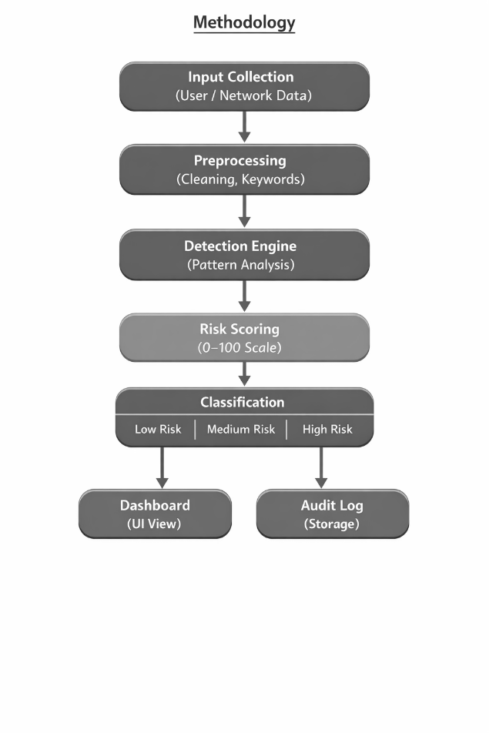
VII. SYSTEM ARCHITECTURE
The system architecture of the proposed CAD (AI-Driven Cyber Anomaly Detection and Secure Audit Logging Framework) is designed as a modular and scalable structure that integrates multiple functional components to ensure efficient cyber threat detection and management. The architecture primarily consists of five key modules: the User Interface (UI), Detection Engine, Risk Scoring Module, Audit Logging System, and Backend Server with Database support. The process begins at the User Interface, which acts as an interactive dashboard allowing administrators to input data and monitor system activities in real time. User or network data collected through the interface is forwarded to the backend server, where it undergoes preprocessing and analysis.The Detection Engine serves as the core component of the system, responsible for analyzing incoming data using a behavior-based approach to identify anomalies. It evaluates patterns and detects deviations from normal activity, forwarding suspicious events to the Risk Scoring Module. This module assigns a dynamic score to each event based on its severity and classifies it into low, medium, or high-risk levels. The classification results are then simultaneously sent to the dashboard for visualization and to the Audit Logging System for secure storage.The Audit Logging System ensures that all events are recorded in a structured and tamper-resistant manner, maintaining data integrity and supporting future forensic analysis. The Backend Server manages communication between all modules and handles data processing efficiently, while the database stores logs and system data for long-term use. The overall architecture ensures a seamless data flow from input collection to detection, evaluation, logging, and visualization, making CAD a reliable, efficient, and extensible cybersecurity framework.

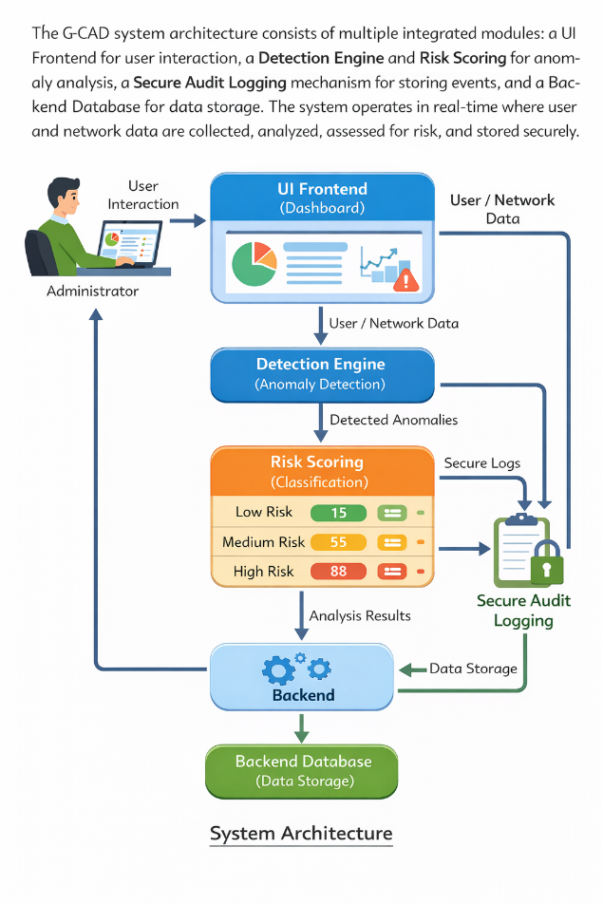

VIII. IMPLEMENTATION
The implementation of the proposed CAD framework is carried out using a combination of modern web and backend technologies to ensure efficiency and scalability. The frontend of the system is developed using HTML, CSS, and JavaScript, which provide a responsive and interactive user interface for real-time monitoring and visualization of cyber threats. The backend is implemented using Python with the Flask framework, enabling efficient handling of user requests, data processing, and communication between system modules. The anomaly detection and risk scoring logic are developed using a rule-based approach combined with dynamic scoring techniques to evaluate user and network activities. For data storage and management, a database system such as MongoDB can be optionally integrated to store audit logs and system data in a structured format. Additionally, visualization components such as charts and dashboards are used to represent risk levels and system activity effectively. Overall, the chosen technologies ensure that the system remains lightweight, flexible, and easy to deploy while supporting real-time cybersecurity analysis.The system is designed with a modular architecture to ensure flexibility and ease of integration between different components. Each module, including the detection engine, risk scoring unit, and audit logging system, is implemented as an independent yet interconnected component within the Flask backend. This modular design allows seamless data flow and simplifies debugging, maintenance, and future upgrades. RESTful APIs are used for communication between the frontend and backend, enabling smooth data exchange and real-time updates on the dashboard.Furthermore, the system is optimized for real-time performance and low computational overhead, making it suitable for deployment in resource-constrained environments. Efficient data handling techniques are applied to process inputs quickly and generate immediate outputs without significant delay. Basic security measures such as input validation and controlled access handling are also incorporated to ensure system reliability. The implementation is structured in such a way that it can be easily extended to include advanced machine learning models or integrated with external security systems, enhancing the overall capability of the CAD framework.
IX. RESULTS
The implementation of the proposed CAD framework demonstrates effective detection of anomalous activities based on behavioral analysis and dynamic risk scoring. The system was tested using various simulated user inputs and activity patterns representing both normal and suspicious behavior. The results indicate that the detection engine successfully identifies anomalies and assigns appropriate risk scores based on the severity of the activity. Events categorized as high risk were accurately flagged, while normal activities were classified under low risk, thereby reducing unnecessary alerts. This shows that the system is capable of distinguishing between legitimate and malicious behavior with reasonable accuracy.The real-time processing capability of the system ensures that activities are analyzed instantly, and the results are immediately reflected on the dashboard. The visualization components, including charts and risk indicators, provide a clear understanding of system activity and threat levels. Additionally, the audit logging module effectively stores all events in a structured format, ensuring traceability and supporting future analysis. The integration of detection, scoring, and logging modules results in a smooth and efficient workflow.Overall, the CAD framework achieves its objective of providing a lightweight, real-time anomaly detection system with dynamic risk evaluation and secure logging. Compared to traditional rule-based systems, it offers improved usability, better threat prioritization, and enhanced transparency. However, the system currently relies on predefined rules and simulated inputs, which may limit its performance in highly complex real-world environments. Future improvements involving machine learning models and real-time network data can further enhance the accuracy and robustness of the system.
Home page:
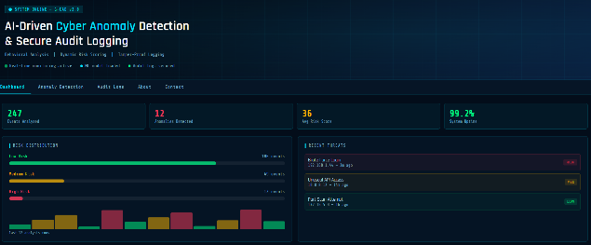
Anomaly Detection:

Brute Force Login:
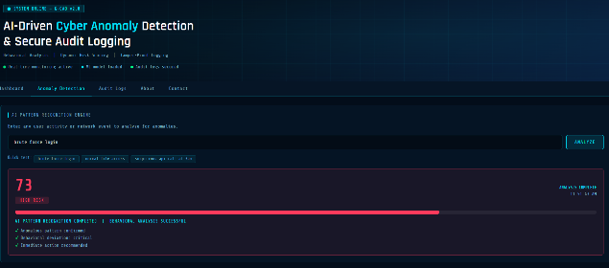
Normal File Access:
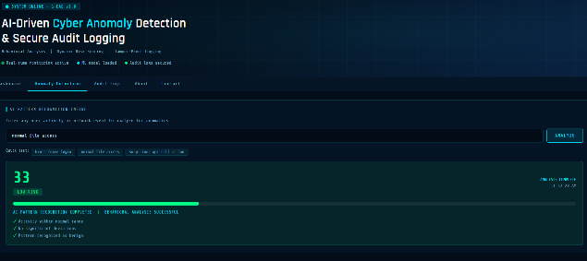

The output generated by the CAD system is structured, informative, and designed to support quick decision-making. For each analyzed activity, the system produces a detailed result that includes the input event, detected anomaly indicators, assigned risk score, and corresponding risk classification. This structured output enables administrators to clearly understand the nature and severity of each event without ambiguity. The inclusion of a numerical risk score provides a quantitative measure of threat intensity, while the classification into low, medium, and high categories simplifies interpretation and prioritization.The visualization of outputs through the dashboard further enhances usability and system effectiveness. Graphical representations such as bar charts, pie charts, and real-time indicators allow users to monitor the distribution of risk levels and overall system activity at a glance. High-risk events are prominently highlighted, ensuring immediate attention, while lower-risk activities are displayed in a less intrusive manner. This visual differentiation helps reduce cognitive load on administrators and improves response efficiency in real-time scenarios. In addition to real-time visualization, the system ensures that all outputs are persistently stored within the audit logging module. Each output entry is recorded with essential metadata, including timestamps, activity descriptions, risk scores, and classification labels. This enables historical analysis, trend identification, and forensic investigation in the event of security incidents. The stored outputs can be reviewed to identify recurring patterns or potential vulnerabilities within the system.Overall, the output of the CAD framework is not only accurate but also highly interpretable and actionable. By combining detailed textual results with intuitive visual representations and secure storage, the system provides a comprehensive view of cybersecurity events. This multi-dimensional output approach significantly enhances the effectiveness of threat monitoring and supports better decision-making compared to traditional systems that provide limited or less structured outputs.
X. CONCLUSION
In this paper, the CAD (AI-Driven Cyber Anomaly Detection and Secure Audit Logging Framework) system is proposed as an effective solution to address the limitations of traditional cybersecurity mechanisms. By integrating behavior-based anomaly detection with dynamic risk scoring and secure audit logging, the framework provides a comprehensive approach to identifying and managing cyber threats in real time. Unlike conventional signature-based systems, CAD is capable of detecting unknown and evolving attacks by analyzing deviations in user and system behavior.The implementation of the system demonstrates that CAD can efficiently classify activities into different risk levels, enabling better prioritization and faster response to potential threats. The inclusion of a web-based interactive dashboard enhances system usability by providing clear visualization of detected anomalies and system activity. Additionally, the secure audit logging mechanism ensures transparency, data integrity, and supports forensic analysis, making the system reliable and accountable.Overall, the proposed framework achieves a balance between accuracy, efficiency, and practicality, making it suitable for real-world applications. While the current system is based on rule-based logic and simulated inputs, it provides a strong foundation for future enhancements. The integration of advanced machine learning models, real-time network traffic analysis, and blockchain-based security mechanisms can further improve the performance and scalability of the system. Thus, CAD represents a promising step toward building intelligent and adaptive cybersecurity solutions for modern digital environments.
XI. ACKNOWLEDGEMENT
It gives a great pleasure in taking privilege to express our gratitude to one and all who have extended their kind gesture to finish our Project work. First and foremost, we would like to express our great gratitude to our beloved the Chairman and Managing Director of our college Dr.SAMPAUL.,M.E.,Ph.D. Principal Dr.A.SIVAKUMAR.,M.E.,Ph.D.,M.I.S.T.E., Christ of Engineering and Technology, Puducherry. I express my sincere thanks to our Project guide Mrs.R.Ranjani.,M.E., Assistant Professor CCET, Department of Information Technology for his valuable guidance, keep interest and timely suggestions given during the entire project. We are thankful and grateful to our Project Coordinator and Head of the Department Mr.J.MANI.,M.E.,Ph.D.,M.I.S.T.E., Department of Information Technology whose great support valuable suggestions eased our work process during the span of this project. We are thanking to all the Staff Members, of the Department of Information Technology for their fullest support and encouragement. Above all we wish to express our wholehearted gratitude to our family members and friends who stood with us throughout the span of this project work. In the praise Almighty we thank one and all
XII. REFERENCES
- H. Rahman and Y. O. Mohamed, “Power system cybersecurity: A survey,” IEEE Access, vol. 8, pp. 111576–111588, 2020.
- R. D. L. et al., “Deep learning for cybersecurity: State-of-the-art and challenges,” IEEE Access, vol. 8, pp. 53841–53870, 2020.
- B. Poudel and C.-H. Kim, “Secure and efficient machine learning for smart grids,” IEEE Trans. Smart Grid, vol. 11, no. 6, pp. 5005–5013, 2020.
- L. Wang, H. Jin, and S. Yang, “LSTM-based detection of cyber-attacks in smart grids,” in Proc. IEEE PESGM, 2020.
- Y. Liu et al., “Deep learning for cybersecurity anomaly detection: A survey,” IEEE Trans. Dependable Secure Comput., vol. 18, pp. 2224–2241, 2021.
- K. Zhao et al., “A survey of anomaly detection methods for IoT systems,” IEEE Access, vol. 9, pp. 128269–128290, 2021.
- A. Sahu et al., “Multi-source data fusion for cyberattack detection,” IEEE Access, vol. 9, pp. 112456–112470, 2021.
- Y. Farrukh et al., “Supervised ML approach for cyber attack detection,” in Proc. IEEE NAPS, 2021.
- V. S. K. et al., “SHAP-enhanced intrusion detection system,” in Proc. ACM SAC, 2023.
- S. Hussain et al., “Hybrid methodology to secure smart grids,” Scientific Reports, vol. 13, 2023.
- A. Sharma, “Machine learning in cybersecurity anomaly detection,” IEEE IoT Journal, vol. 9, pp. 7123–7133, 2023.
- N. Jeffrey et al., “Anomaly detection strategies for cyber-physical systems,” Electronics, vol. 12, 2023.
- A. Aljohani et al., “Deep learning-based intrusion detection system,” IEEE Trans. AI, vol. 5, 2024.
- A. Choppadandi et al., “Anomaly detection using ML algorithms,” JETA, 2024.
- “Anomaly detection using machine learning for intrusion detection,” IEEE Conf., 2024.
- A. Aparcana-Tasayco et al., “Anomaly detection in IoT security: A review,” EPJ Quantum Technology, 2025.
- A. Almuhanna et al., “Hybrid deep learning for anomaly detection,” Frontiers in AI, 2025.
- “AI-driven cybersecurity framework for anomaly detection,” Scientific Reports, 2025.
- M. Ali et al., “Deep learning vs ML in intrusion detection,” Applied Sciences, 2025.
- S. Jamshidi et al., “ML-based intrusion detection in IoT,” Computers & Industrial Engineering, 2025.
- M. Priyadarsini and N. Sonekar, “CNN-based anomaly detection,” Electric Power Systems Research, 2025.
- Y. Ghosh et al., “Explainable AI in cybersecurity,” ACM Computing Surveys, 2021.
- N. Wang and Y. Chen, “Adversarial ML in cybersecurity,” IEEE Trans. Neural Networks, 2022.
- P. Ghosh and A. Ghosal, “Explainable AI for cyber defense,” 2021.
- C. Zhou et al., “Information fusion for cybersecurity,” Information Fusion, 2020.
- V. Kovtun et al., “Cyber-physical attack detection model,” Scientific Reports, 2022.
- B. Lunardi et al., “ARCADE deep learning anomaly detection,” 2022.
- D. Bierbrauer et al., “Anomaly detection in adversarial environments,” 2021.
- L. Jiang et al., “Graph neural networks for anomaly detection,” 2025.
- F. Leveni, “Structure-based anomaly detection methods,” 2025.
- A. Aparcana-Tasayco et al., “Quantum ML for anomaly detection,” 2025.
- “Cyber-physical systems anomaly detection review,” ScienceDirect, 2026.
- P. Pinto et al., “Attack detection in cyber-physical systems,” IEEE ETFA, 2020.
- D. Plakhotnikov et al., “AI in cyber-physical systems,” IEEE SCM, 2020.
- B. Pranto et al., “ML techniques in intrusion detection,” J. Adv. Info Tech., 2022.

